FA045
Flexible, fast and compact
Mobile data acquisition in the industrial environment requires a robust housing technology
Author: Hendrik Thiel HEITEC AG, International Sales Manager Business Unit Electronics
Today, mobile and Internet-based data acquisition together with the appropriate communication tools are an integral part of the production lines in many industrial companies, and they have become a critical factor of success in a market, where IT and automation are getting closer and closer. Many processes can thus run faster, more efficient, more flexible and more cost-effective, but this also places high demands on the applications. They must be modular, fast, reliable, easy to use and robust. High standards apply not only for the electronics, but also for the mechanics, which is particularly required for use in a production environment, that is sometimes contaminated: The systems must even function reliably, when there are major temperature changes, heat, heavy shocks and vibrations, and they must be resistant to water, dust, lubricants or toxins. Reliability and easy maintainability are the highest demands on the concept of the equipment and the system integration–always in compliance with the technical specifications. In this case, it is ideal to work with a partner who pursues system integration as well as provides the appropriate package of electronics and mechanics.
The electronics division of HEITEC has implemented the complete system integration (Level 5) for a mobile, industrial data acquisition system of the system specialist MAHLE Filter Systems GmbH, a subsidiary of the leading global automotive supplier MAHLE. The complex hardware and software system is used worldwide for mobile acquisition of measured data in the internal development of liquid filtration systems. The so-called data logger collects the required data via four integrated measuring modules (voltage, sensor bridge, counter and temperature module) that can operate in different modes. The captured data can then be easily transferred via USB to a laptop for storage or evaluation.
Housing technology
After a detailed requirement analysis, the company decided to use a Ripac Vario module (3 HU, 42 DU and 310 mm depth) including mounting plate of HEITEC’S standard system portfolio as the system basis. This was not only a cost-effective solution, but was apparently well suited based on its compact and robust all-metal enclosure construction. Due to its modular structure, the housing family is ideal for individual configuration and for customization and allows for a high packing density. The sidewalls and transverse profiles consist of extruded aluminum profiles, while the corner elements are made of robust die-cast zinc. Sidewalls, side panels, horizontal rails and threaded strips are also included with standard delivery. Front panel and rear wall were designed by HEITEC according to the customer’s corporate design specifications.
The front panel got two front handles to protect the measuring sockets and to enable a better handling. The front panel carries the connectors for the sensors connecting to the four modules and the power LEDs. Furthermore, corner plates were installed for use as a mobile housing and handles were mounted for ergonomic transport. The HEITEC cover plate was also equipped with grab bars. On the back there is a switchable combination module for the power input, a safety socket including a cover for the power supply, a USB port for the laptop connection and a fastening device for the external power supply. In order to protect the cover plate against contamination it is covered by an oil-resistant protective rubber. On special customer request the 230-Volt connection of the Power Supply Unit to the socket, and each 24-volt power supply of the measuring modules were conceived. In addition, a rear mounted terminal for the complete grounding of the system as well as a special suspension for a laptop power supply are available. This guarantees the easy connection of a laptop for data processing.
The protection against external malicious influences had also an impact on the technical inner-life of the system. In order to prevent dirt from penetrating into the housing, the use of fans was deliberately not considered - despite of the required 230 Volt power, an AC/DC power supply and an internal 24 Volts power management for the components delivered by the customer, quite literally on the "working" probes. In view of electromagnetic compatibility (EMC) and heat regulation it was carefully considered to position the components in appropriate distances to ensure passive heat dissipation for the entire system.
It was important to consider some other aspects in the system design: First, the measurement types provided by the customer had to be integrated differently because of their different typology. On the other hand, the system has comprehensive communication links, a number of interfaces and a highly functional bus system, based on components from National Instruments to provide the required power to capture and buffer large amounts of data and to output them to an external laptop. This in turn has put high demands on the extensive cabling, i.e. high performance on one hand, and low heat generation, EMC, maintaining of the performance, and especially good accessibility for any necessary servicing issues on the other side. HEITEC developed a highly sophisticated wiring scheme for the power supply in the system, from the power input via the internal 24-volt power supply to the individual measuring systems. Front and rear walls were completely wired; this also applied to the measurement modules with the front connectors, where thermal cables with a specific cable resistance were used.
In consultation with the customer, HEITEC used standard components from National Instruments as much as possible and standardized software tools for data analysis. In combination with its own "best-of" solution concepts based on the "design-to-cost” idea HEITEC could realize a cost-effective overall system. The data logger simply connects via a USB with a laptop and the power supply and is thus immediately ready for use. The measurement data are processed in LabVIEW and can be distributed and reused in the network.

Summary
In this project HEITEC has effectively demonstrated its integration expertise, both from a technical as well as commercial point of view. It only took half a year from conception to final acceptance of the prototypes. HEITEC will continue to produce the mobile data logger out-of-the-box to be used worldwide.
Quote by MAHLE:
For a global company like MAHLE such a customer-oriented all-in-one solution of a data acquisition system is an important pillar in the efficient product development and will also be indispensable in the future.
Picture source: MAHLE Filtersysteme GmbH
Figure 1: Mobile data acquisition system MDA c9174
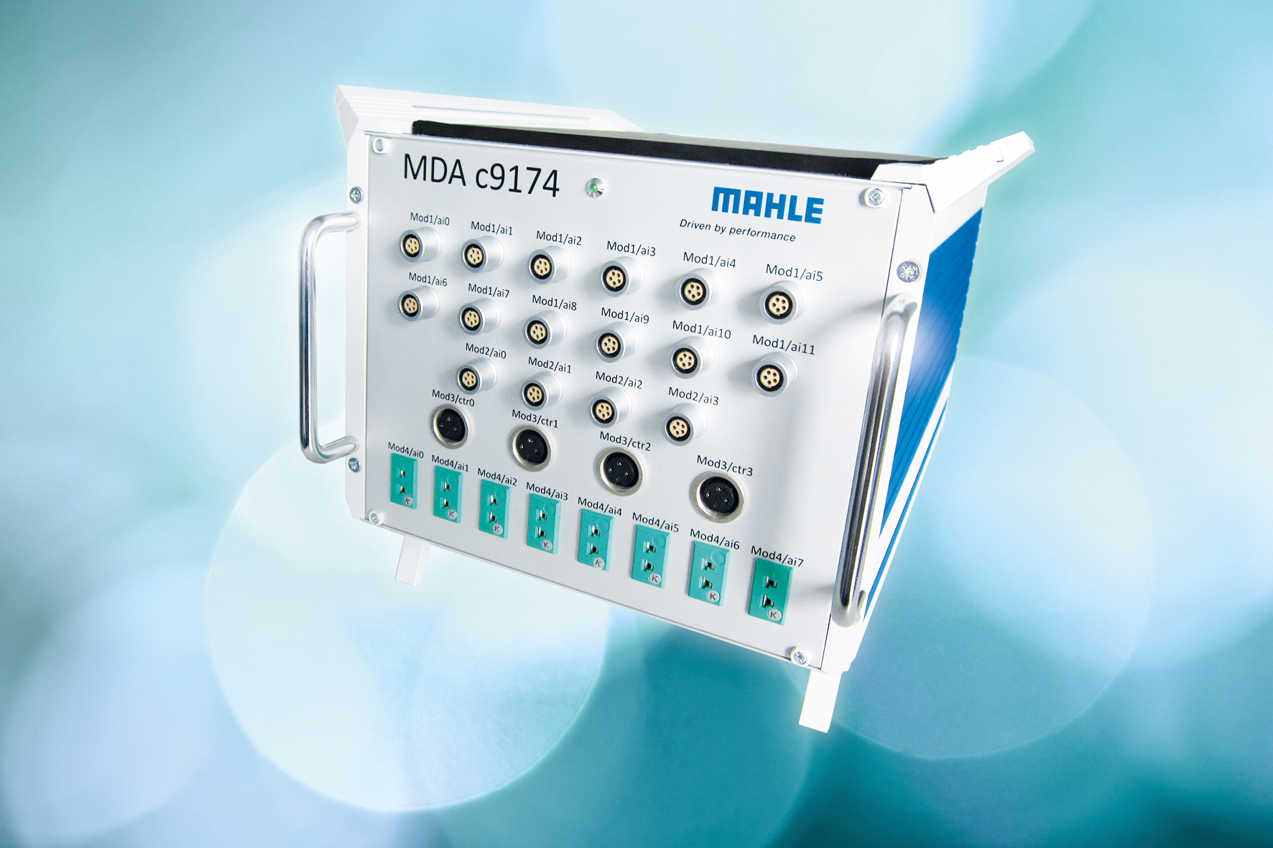

Figure 2: Schematic rear view MDA c9174 (note: inscription to be changed upon request).
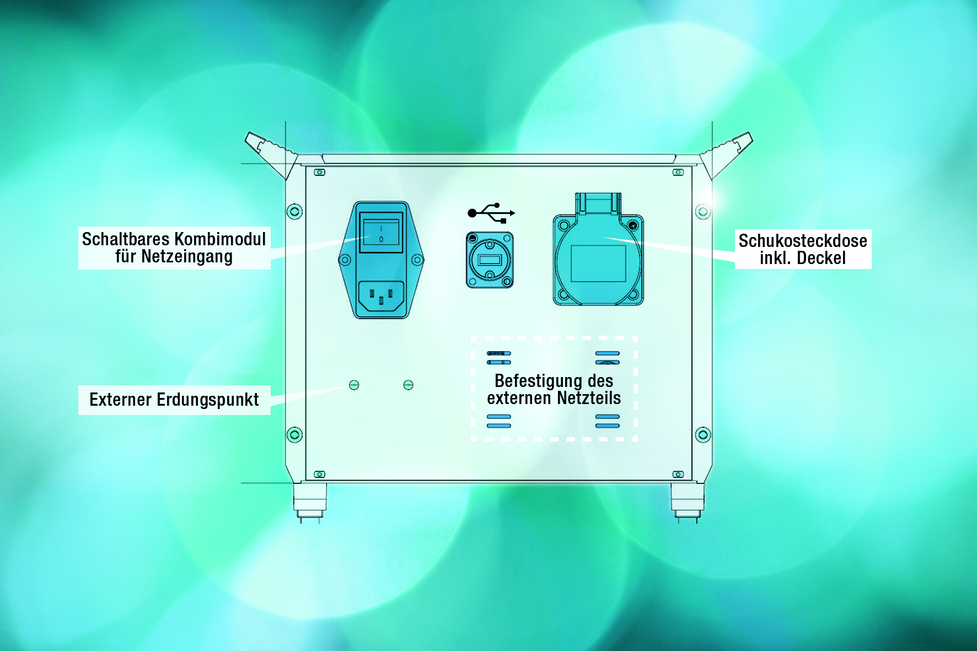

Hendrik Thiel, HEITEC AG, International Sales Manager Business Unit Electronics

HEITEC Corporate Profile
HEITEC represents industry expertise in automation and electronics and offers solutions, products and services in the field of software, mechanics and electronics.
In early 2013, HEITEC took over the complete electronics packaging systems line from RITTAL and with it, the development, manufacturing and sales of all standard articles and customer-specific solutions for Europe and worldwide.
Over 2000 customers increase their productivity and optimize their products with the help of HEITEC's state-of-the-art, reliable and economic system solutions.
A work force of 1000 employees at numerous sites worldwide provides high-quality industry skills close to the customer. More than 60% of HEITEC’s employees hold a graduate or postgraduate degree in technology.
During the last years HEITEC has grown substantially more than 10% – doubling its turnover within five years.

PCW Technology
Unit 11, Test Valley Industrial Estate
Nursling, Southampton
SO16 9JW

Telephone
02380 863764

